

A Coast to Coast Adventure.

- or -

And still they battled on…

This is the story of the Coast to Coast Run, an adventure involving members of Marlborough Running Club.

On Saturday 23 July 2004 they set off for the north of England, optimistic, relatively fit, and in reality totally unprepared for what they were to encounter.

The heroes are: Nicola Ashton, Debbie Simpson, Simon Hewitt, Pete Horsell, Chris Wardell, Phil Griffiths. They were magnificently supported by Anne Chandler-Smith, Jenny Griffiths and Tim Ashton. They were accompanied along part of the route by Paul and Joanna.

This ode is based on contemporaneous notes. The author accepts no responsibility for any inaccuracies, nor will he enter into any libel cases. Frankly, his brain is addled after all that running…

OUR SINCERE THANKS TO:

To: Anne, Jenny, Tim (supporters); Simon and Pete (both for making it happen and running it), Nic, Chris, Debbie (valiant runners); Paul, Joanna (friends on the route); MRC members for their good wishes and support; everyone who contributed to MacMillan Cancer Relief; YHA;

…and not forgetting A. Wainwright.

Day Zero - Saturday

It’s Saturday night and it’s pissing with rain
It’s the start of a valiant tale
And the Marlborough team are ensconced in the pub
With some rather good Cumbrian Ale.

It had started quite well, (even Debbie on time)
And the bus seemed to have what it takes;
And despite the M6 and its damned roadwork tricks
We’d arrived at the hills and the lakes.

There’s a hostel of sorts at the end of the lake
In Ennerdale – nowt for a mile;
But it’s tatty and grey and a long, long day
Is ended with a scowl not a smile.

(Do NOT order porridge for breakfast.)

But back to the pub, where the team are on form
And the locals look almost quite posh,
And Waddle and Anne shake their tins all around
And relieve them of their hard-earned dosh.

And still they battled on…back to the hostel

A builder from Ennerdale Lake
Decided some money to make.
So his bread he did butter
By using cheap gutter;
Which kept all the runners awake.

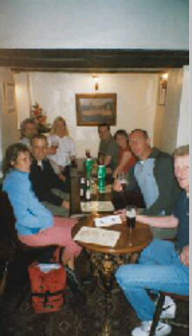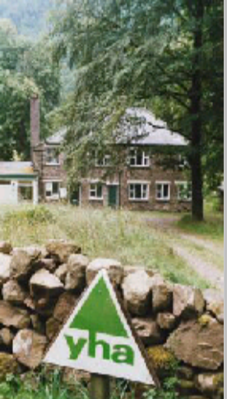

Day One - Sunday

So, Sunday began with the merest monsoon
It’s grey and it’s cold and it’s soggy
And we’re all strapping on our Saucony off-roads
‘Cos the going is sure to be boggy.

And now, a minor miracle…

St Bees, oh St Bees, I go down on my knees
And whimper and worship and cry
‘Cos I just can’t believe it and none of us can -
It’s still blowing a gale … but it’s DRY!

Lace your shoe, get a stone,
Oh there’s far too much choice
For one of our number at least.
Then up on the cliff top and battle the wind
Hey guys, isn’t that way the East?

Ah, but Wainwright, you know, was a cunning old sod
He preferred that his route wasn’t guessed
By the masses and grockles and hundreds of peeps;
So he walked quite determinedly West.

Time to start the battle.

And we’re off! Yes we’ve started
We’re running uphill
That won’t last a few minutes, we know.
There’s a view over Sellafield down to the south
But a lighthouse is soon “way to go”.

Then down a few fields
And past a few cows
And under a railway or two
And there’s sheep
And there’s chicken
And cattle
And farms
And tracks
And a village to view…

And yes! A support stop…

Now here I must say that our heroes are valiant and strong,
But they cannot compare with the fortitude shown
By supporters throughout the day long.
Providers of tea, with greetings and smiles,
With plasters and sweeties and balm,
Who put up with the sweat and the feet and the tears
And through it all somehow stay calm!

We’re only just coming to lunchtime
And we’re only on day Number One,
But Phil’s leg‘s decidedly dodgy
He walks to the lunch stop – can’t run.

Oh dear.
Ah – but Debbie’s the girl in the know
About ankle, and elbow, and toe.
So she slapped on some ice
Raised his heel in a trice
And voila – he’s soon on the go.

But – still oh dear…

Now Nicola’s had an odd turn
It’s really quite strange and unfair;
But Nursey has come to the rescue
By raising her feet in the air.

And still they battled on… afternoon, day One.

Now just after lunch there’s our first minor hitch
When the bus makes a small navigational glitch
And the runners arrive at their planned rendezvous
Before the supporters – a minute or two.

But all’s well and we’re running on Ennerdale’s shore
And there’s grass
And there’s boulders
And gravel and more;
And the rain that so cruelly deprived us of sleep
Has now flooded the path a good six inches deep.
There’s no sense in leaping to miss the parts boggy
Whatever you do you’ll have feet that are soggy:
But fear not – the sun’s shining down from High Stile
And your socks will be dried out within the next mile.

A brief word at this stage. In this long afternoon
Our kind helpers are way out of sight;
‘Cos there’s no meeting point through to Honister Pass
Where we’re hoping to stay for the night;
So we yomp on past Haystacks - we didn’t go up
As we couldn’t determine the way;
And on to Black Sail, with a sheep in the hut,
And Simon’s nostalgic
And Chris isn’t but
He chats up a runner from down Hampshire way
And we’re close to the end of a fabulous day…
Just a matter of climbing a few hundred metres
In the glare of the sun -
We won’t let it defeat us .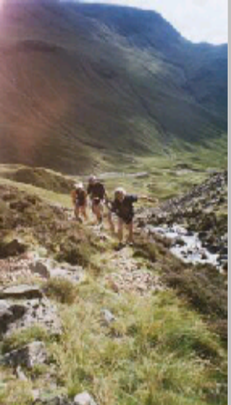
And on to the top and look back to the sea:
Here’s where Debbie exclaimed “Oh my word, Goodness me!”
Well, that’s what she claims, as we stood with our packs on;
But maybe her words were a bit Anglo Saxon.

Now down the long track past the mines and the slate
Hey - there’s the bus! Anne and Tim! There’s the Youth Hostel!
Great!!

But a teensie correction of what went before,
For Tim wasn’t waiting at Honister’s door.
Poor lad had been left keeping tables for grub,
And had suffered a couple of hours in the pub.

Soon, all showered, sweet smelling, we bounce down the hill
In the bus to the pub, pints of bitter to swill.
More collecting, more yarns, lots of chips – sweet aroma!
Then back to the Hostel;
Collapse in a coma.

Writer’s note.

I reserve the right to record random trivia about each day, including those events that can’t be turned to rhyme (by me, anyway). So, for completeness, Day One also included:

“Thank you, Marshall!”
Chris, greasing moving parts, in full view of diners
Debbie lumbers Paul with luggage
Chris hoping to rescue a badly injured sheep

Here’s the sort of quality you get when you try to develop Limericks on the run…

A chappie from Honister Hill  Woke up feeling groggy and ill.  He’d been sh***ing a sheep  Till they both fell asleep  Now he’s hoping the ewe’s on the pill. | An entrepreneur from Seatoller  Had ambitions that featured the dollar.  So he left for the States  Where he sold paper plates.  “Come and buy some of mine!” he would holler.

How to keep contact between runners and bus, when mobiles don’t work?

Bus control to Running Throng
Bus control to Running Throng
Get your arse in gear, we’ve put the kettle on!

Running Throng to Bus control
Running Throng to Bus control
Debbie’s hurt her knee
And needs a skiing pole…

This is Running Throng to Bus control, we’ve made it to the lake
And we’re running in a most peculiar way
And the sheep look rather beautiful today…

(Aren’t two-way radios a great idea?) (…and apologies to David Bowie.)
And still they battled on…

Day Two - Monday

Now picture sunlight dappled on green hills
And beauty as the day begins to break.
Our runners, seeming free from aches and ills
From hostel cautious morning steps do take.

“Downhill”. The word is floating on the air
And birdsong greets the promise of a start
That even coughing Simon thinks is fair
And so our brave marauderers depart
To Seatoller in Borrowdale’s green vale
Straight through and on to Rossthwaite, where our Anne
Has managed to chat up a local male
But sadly also pranged the mini-van.

But we’re out of the vale in a moment or so
And we now face a heck of a hill
From Stonethwaite we’re headed right up Greenup Edge
By a beautiful, bubbling gill.

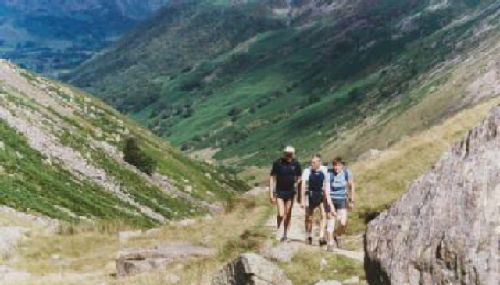

It’s a thumping great climb
We have scrambles and bogs and the going is generally slow
Till we get to the top and reality dawns - the support stop is two miles below;
Down a difficult path that is rocky and hard, it seems that we’ll never get there.
The group gets spread out; some are flying downhill
While others hold back and take care.

But in time Wordsworth’s path through the woodland is here
And back markers, who’ve built up a thirst,
Follow through leafy glade to a welcoming stop
At Lancrigg – and find that they’re first!

(Guess who missed the turning?)

Ah Lancrigg Hotel, dear Lancrigg Hotel
I’ve been here quite often before,
But never was tea on the lawn such a treat -
But then, never were feet quite so sore.

Our lunch was in a pull-in just beyond the hotel’s view
Out of sight of puzzled diners, past the hedge.
And fortified with Tracker bars, with sandwiches and rice,
We set off again – direction: Striding Edge.

And still they….

But now, dear reader, let’s confess
Let all pretending stop.
There is no way that you’ll get me
Upon Hellvelyn’s top.

I’ve see some shots of Striding Edge
They make my kneecaps quake
So, Pete and Simon, off you go;
The lower path I’ll take.

But “lower” still includes a climb
With wondrous Grasmere views
In burning sunshine, half way up
Young Debbie takes a snooze!

She’s checked the slope, the cunning lass
And given Paul her pack.
But even lightened, half way up
She’s sleeping on the track.

[Running hint number One:

Have you heard about “collagen moments”?
It’s one of our hill runner’s tips.
Whenever the hill just refuses to end,
You keep seeing them: lots of false lips!]

But onwards and upwards towards Grisedale tarn
And the prospect of downhill to come;
No sign of our colleagues, no Simon or Pete,
Their route far too scary for some.
For they chose to attempt a much loftier path
The lure of Hellvelyn too great;
On a track that would take them to feared Striding Edge,
They’d set off at a hell of a rate.
Their intention, of course, as competitive lads
Was to hurtle along to the bus;
With the rest of us slow as a rambling club
They’d a very good chance to beat us.

But with great bursts of speed and a hastening step
The four of us pushed on downhill;
With Chris Wardell ahead, just bouncing along –
(there are times when he makes you quite ill.)

But blood is spilled upon this Cumbrian vale
And Brave Sir Simon suffers injured knee,
But does it slow him? From it does he ail?
No problem: you know Simon as do we.

We know our Simon’s made of sterner stuff,
No minor cut will make this tough guy late;
He charges down the hillside, sure enough
With Pete, for picnic by the pasture gate.

So just a mile. Another day complete.
Yet still some views: the steamers on the lake,
And Patterdale, the hostel, rest your feet;
There’ll be more tests tomorrow when you wake.

The hostel at Patterdale, set among trees
With the food served upstairs, has a menu to please;
But the showers are basic, steamed mirrors and sinks
And you’d never believe how the drying room stinks.

The room where we’re sleeping is huge, which is great
When you think that it has to accommodate eight!
We’re all in together, which is really quite cheering
Till Debbie announces that she’s lost an earring.
Pete’s broken his glasses - that could be a loss,
But he says that to fix them he’ll use dental floss.
(Snatching victory from the teeth of defeat.)

The earring’s still missing, we’ve had evening grub
And the lads fancy beer, so we walk to the pub.

At the Inn of the Living Dead…

Stop all the clocks.
Reduce the tuneful jukebox to a sombre tone.
Lower the lights.
Sit Mabel in the corner with her stout. Alone.
Get in a round and sit square at the table,
Voices low….

Did someone die? In here? Recently?

The beer was called “Doris’s 90th”
A pretty good pint, most would say.
So we walloped down three or four pints of it,
And went back to the hostel. Hooray.

Still no earring?
Have you tried
Your running shoes
Might be inside…

Other notes on Day 2:

Debbie started the day with a cartwheel.
And then took her shirt off…
Tea on the lawn at Lancrigg – how civilised.
There were Germans in the showers.
But Nicola’s spider was probably English 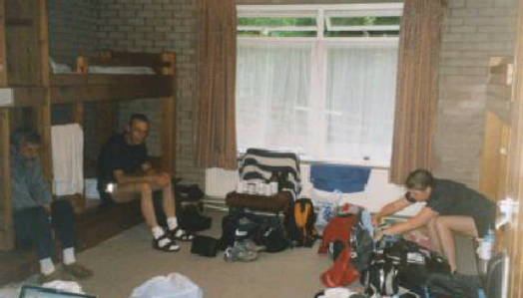

And still they battled on…

Tuesday. Day Three.

What a morning. Bloody hell!
Enormous climbs, right from the start.
Yet at this stage we had no clue,
No vision of the toil ahead,
No thought of all the angst to come
No quaking of the heart.

It’s just another lengthy climb
The last part of the Lakes today;
We know that Kidsty Pike’s to come,
The highest point along the way.

But just to add a little spice,
As if the hills on which we trod
Were not sufficient in their height –
We added in an extra Dodd!

Two-fifty metres extra climb!
We stood there absolutely whacked;
And realised that we had goofed,
A clear eye on the map we lacked.

Bugger!

A hint of tension in the air.
There are some who
Are less then chuffed
That navigation has been fluffed
But no need for despair.

The sky is blue
The sun is hot,
Direction’s right
And Kidsty Pike is soon in sight,
The high point of our trot.

I haven’t yet mentioned Joanna
A walker we met on this day.
It seems she’s a Brit
But her accent’s more fit
For the Yanks’ Appalachian Way.

She’s walking the trail on her lonesome
It seems she split up from her man.
She says “If you’re forced
To get a divorce
Just take a long walk if you can.”

[Running hint number 2:
How to annoy a runner:
It’s easy if you try.
Just tell them you’re walking the footpath.
Whenever they stop, just stroll by.]

Mardale used to be a village
Snoozing by the long lake shore
Till Mancunians needed water
Now it’s not there any more.

So we run along Haweswater, hot in bracken, pray for shade,
Pass the dam then find supporters:
With a shelter ready made.

Lunch – fantastic!
What a morning!
So much climb and so much heat,
Aching muscles, sweaty foreheads,
Steaming shoes and smelly feet.

Cups of tea and
Juice of orange,
Small rice puddings
Taste so nice.
Nuts ‘n raisins
Tuna sandwich
Mr Kipling’s Country Slice.

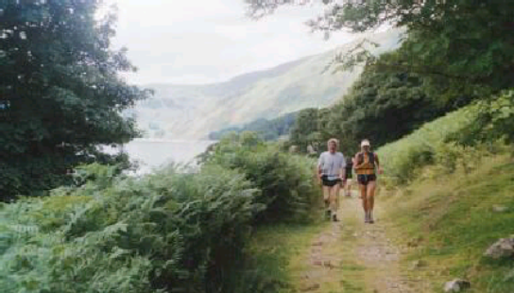

And still they battled on…

Tuesday afternoon. Dark clouds loom?

With the sun in the sky
And a tough morning done
We set of ‘cross green fields
Flat and easy to run.
A glistening stream
And an old packhorse bridge
To the view of Shap Abbey
Down below a small ridge.

All is well…

Until we enter Shap.

Come friendly bombs and fall on Shap.
The place deserves it.
Total crap.

It’s hot and it’s dusty and sticky and tiring.
You’ve been slogging along, feet aching, perspiring.
But in the next street there’s a reason for cheer
As the plan says the Magic Support Bus is here.

Where…?
Where?
Where is it?
How far?
Just down here –
Just down where?
Can’t see it.
How long’s this road?
By the pub.
Which pub?

How can there be five bloody pubs and it’s at the last sodding one of the whole pigging lot a bleeding mile down the road from where we bloody hoped it would be, sod it?

And then the toys fly out of the pram;
I know you’re knackered and I sure am.
So we swear at each other (it still rings in my ears)
And the whole Big Adventure almost ends in tears.

Bugger! Again.

But somehow we’re made of sterner stuff,
Somehow we get out of this fix.
There are fields to cross and tracks to plod,
Hey! We’re crossing our friend, the M6.

Meanwhile Simon
Missed our blues,
Busy buying
Running shoes!
Nowhere near us
When we crossed
The motorway - hope he’s not lost.

On to the moors east of Shap
Past layers of beautiful rock
A tarn and a bridge
And a shortcut and then
Oh curses…we’d better take stock;
‘Cos we’re lost; dodgy shortcut.
There’s a farmhouse ahead but
We’d best not climb over his wall.
So we head for the road
Pass the farm back on track
Knowing that soon we’ll end the day’s hack
With the wonderful sight of a welcoming bus
At a grid made for cattle - the last stop for us.

By the way, Pete and Chris
Had bounded ahead
With the speed of two cheetahs on heat;
But they also got lost
So they went via the road,
And cut off half a mile. Now, that’s neat!

From its stop in the midst of the hills
The bus took us down to the town,
Kirby Steven had put up the shutters
The whole bloody place had closed down.

But we’re gasping for food
So our crew start a quest,
And Anne’s the first back
With the Spar grocer’s best;

And then Tim rushes in
Looking smart (he’s no hippie)
He’s bought all that’s left
From the chap at the chippie.

So a feast in a chapel,
Then crash for the night.
The prediction “Day Three will be tough” was quite right!

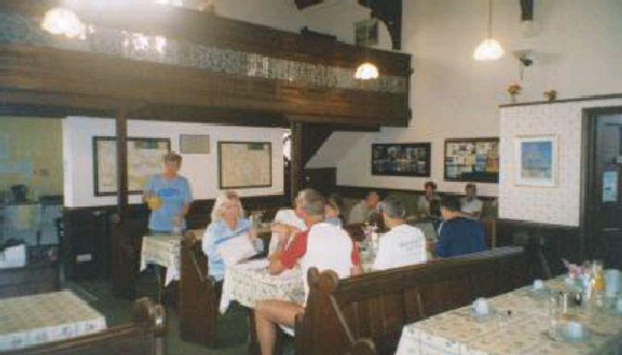

Day 3 – other recollections

Got to the bus at 8.05 pm – now that’s late!
Pete and Chris saw a hen harrier
Fly past by two Hawk trainers at Haweswater
Jenny’s on the way!

We left the Lakes. Sad to go, but they almost finished us, so we’re relieved at the prospect of kinder terrain.

And still, for reasons best known to themselves, they battled on…

Wednesday. Day 4.

Today we’re joined by Jenny, traveller brave
Who’s made the trip oop north by Virgin Rail.
Why would she want to join these madcap loons?
Enough to make a top supporter quail!

A breakfast, then a bus ride to the moor:
You start the way you mean to set the day.
Come on then chaps, don’t hide inside van door,
Away we go – hang on, that’s not the proper way.

Today the Dales await: untrodden ground
Revealing stunning views that would astound
We novices, who are not Yorkshire bred.
(Strong in the Wiltshire leg, not in the head?)

Back into Kirby Steven, bustling town,
We shock the locals with a change of socks!
We take a break outside the local court.
In days gone by we’d have been in the stocks.

We meet a bunch of walkers carrying pans
With kit sufficient for a fortnight’s trek
So far they’d walked the path a full nine days.
“You’re running all the way? Cor, flippin heck!”

Now up to t’moors, a long and painful climb,
We find Nine Standards, magic stacks of slate;
Pass walking Mum, with little girl in pink
A junior walker, doing really great!

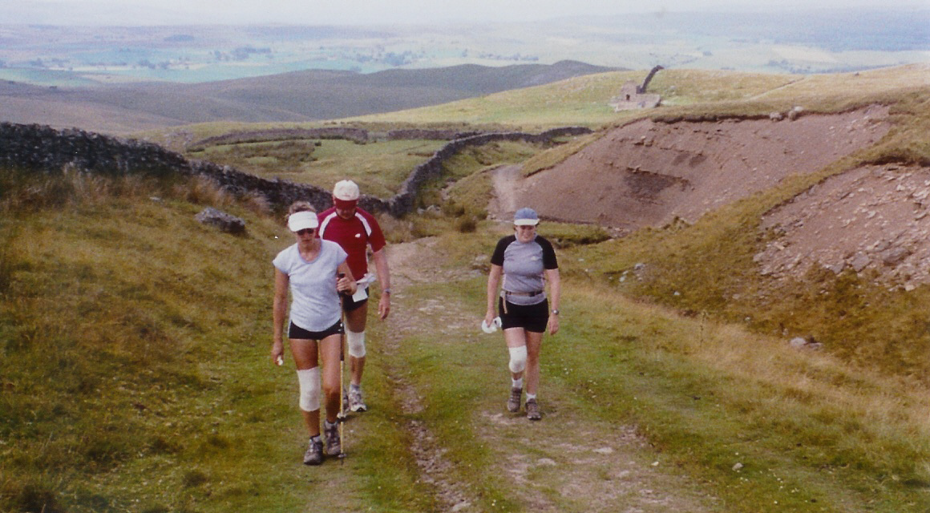
The sky is black
The wind is growing strong
It will be pissing down on us
Before too long.

We thought the storm was on the way
But someone smiled from way up high.
No doubt it poured in local vale
But our brave team remained quite dry.

Yet underfoot was really mad.
We’re on peat moors, we bounce along.
Until we find the soggy bits
Where one can get it really wrong!

…and someone did. As o’er the peat we flew
A splendid leap from Phil,
On landing, left behind his shoe
In oozing black stuff, filling up with water.
Midst much hilarity from all
Especially his daughter!

On the moorland the running was easy
Unless both your knees are quite rough
Today was when Debbie began to find out
That this route was incredibly tough.
So running downhill is a pleasure
For the rest of us - Deb won’t agree,
As she struggles along with a pole in each hand
And a sickening pain in each knee.

Now there’s Keld; a small village
Deep down in the Dales,
You could pass it with hardly a glance.
Take the left, pass the church, where displayed on the wall
The locals have laid out their washing for all
To see.
But hey guys - let’s cheer.
‘Cos half way is here!

Keld is half way. But, believe it or not, they decide to keep battling on…

Now the scenery’s fab:
Yorkshire’s Dales are unique
With vast empty moorland and river and peak
Down through valleys, up hillsides
Past lonely farm house
To the heather and wild flowers;
Then you meet them – the grouse.

“Polish my Purdeys, Baldrick.
That’s what I pay you to do.
Load all the chambers with cartridge
I’m going to bag me a few!
The keepers have bred them for shooting
They tell me their life is quite short.
But frankly that doesn’t concern me.
Goddamit! It’s wonderful sport!”

At the top of a long track, a tough, hairy climb
I recovered and took in the views
While the grouse scuttle round in the heather close by
I just couldn’t tell them the news.
There were tyre marks and “grouse pens”
Professional stuff
The tools of the rich shooters’ day.
But the innocent birds aren’t aware of their fate:
Twelfth of August, just two weeks away.

A few more thoughts on this fourth day
The scenery amazing in the hills
The wildlife, snipe and weasel catch our eye
While keeping fit’s a battle of the wills.
Deb’s dodgy knees and Nic has lost a nail,
She’ll find it somewhere in a Yorkshire Dale!

And I really must say
That some time on this day
Though quite when isn’t clear from my log,
The feel of the ground
Which was fine all around
Became very much like a bog.
And one of our team
(She will know who I mean)
A mite careless and pushing her luck,
Was enveloped in ooze
And proclaimed the sad news
With the famous line
“F***, f***, I’m stuck!”

A long, grim slog towards the finish line
With scars of mining long since left to rust.
Support folk keep us trudging slowly on -
We’ll be there soon. A beer becomes a must;
And though the track was difficult to find
And different paths we sought; yet all descend
To Reeth, a warming, welcome sight:
The town,
The square,
The pub,
The beer –
The end!

So, Day 4?

Magnificent Swaledale – taught us that the Dales can match the Lakes (well, almost…)
The ruins of Crackpot Hall
Hot sunshine on tough climbs
Where did that rain storm go?
Pete with a pint of Black Sheep in Reeth
The pub that night – Debbie falls asleep in the window seat; Tim foregoes Bread & Butter pudding so that we can have some (a hero!)
Fantastic Youth Hostel – old shooting lodge, but we don’t hold that against it
Trying to stop Chris vandalising the shooting stands
Nic got the navigation right at the end (they went wrong!)

Quote of the week.

“I woke up and thought I’d gone deaf.” Anne, who for once didn’t share a room with Debbie, who had stayed with Paul’s family in Kirkby Steven overnight.

Thursday – Day 5

The fifth day of battling on. Is there no stopping these loons?

A shooting lodge breakfast,
A slightly misty day;
Gather all the bags up
And the bus is under way.
Getting through the archway’s tough
It goes ok beneath
And once it squeezed between the walls
We’re off – to start at Reeth.
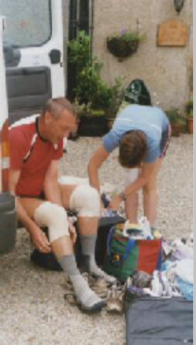
We pick up where we stopped last night,
The pub now closed and dark -
The village green in early morn
A place where shooters park.
A chatter of murderous Barbours,
Enough shells for a bomb;
Later in the peaceful hills
They imitate the Somme.

But on to the moors
The weather amazingly good
Into a day that, along the way,
Featured fun with drink and food.
Two pubs that just weren’t open,
One that especially for us
Opened up its door and found
Drinks, with smiles, no fuss.

Dear reader, by now you must know
That Coast-to-Coast’s a magic trail.
You’ve heard of moorland, peat and stream,
Of river, hill and Yorkshire dale.
But parts are difficult to find
Will challenge navigator’s art
And losing track in early morn
Can cause a sinking of the heart.

We’re running off through pastures green
With cattle looking on, askance,
Who warn their offspring – “Keep away
You don’t know where those beasts have been!”
On most of our route to this stage
We’d seen village and hamlet and farm
But soon bustling Richmond appears
A town steeped in history and charm.

A market place crammed full of shoppers
With office staff having a break
Quite oddly, to us, they’re quite fazed by our bus
A full market-day double take!

Then off to the country again
And the limbs are feeling like lead:
Debbie’s limping, Simon’s coughing,
Nic and I are simply dead.

A tiring day, the sun beats down
And Nic, who’s lost a page of map
Is battling on against the heat
But carrying a frown.

Later on the scorching trail
We spot a pub, oh wondrous sight!
We’re desperate for grub, for chips
For anywhere to crash and so
We push along the road in hope
We even lift our trudging pace, but…
The sodding place is shut.

Shut?!
How can a pub, in Yorkshire’s golden dales
Batten its doors to passers-by
Denying them pies and ales?
How can a landlord simply fly
Leaving a rural idyll closed,
Leaving runners hot and dry?

It’s enough to stop a team battling on….

But no…

…we sat in the shade
Took refreshments on board
And slowly recovered our wits
And despite the sheer lack
Of ice cream or chips
We hadn’t quite fallen to bits.

Across further fields
Past a farmhouse or two
And we’re making slow progress once more
We knew that ahead lay Catterick Bridge,
And some beer and a sandwich in store.

Guess what, the bloody place was shut!
“Oh, not again!” I hear you yell.
But brave supporters found us drinks
I think they gave the landlord hell…

There follows now a change of scene
Eight miles of seeming endless road
No contours, not a hill in sight,
No stream or lake to lighten load.
We’re all spread out, some fast, some slow,
It feels like miles and miles to go.

But Hey! and Woo! and Hark! and Hisk!
(What else would rhyme with Danby Wiske?)
We find a pub on village green
Shut - dozing in the afternoon,
But lady owner, kind and keen
Comes out with drinks – a Yorkshire boon!

If ever you’re in ‘tYorkshire Dales,
The White Swan is the place for ales!
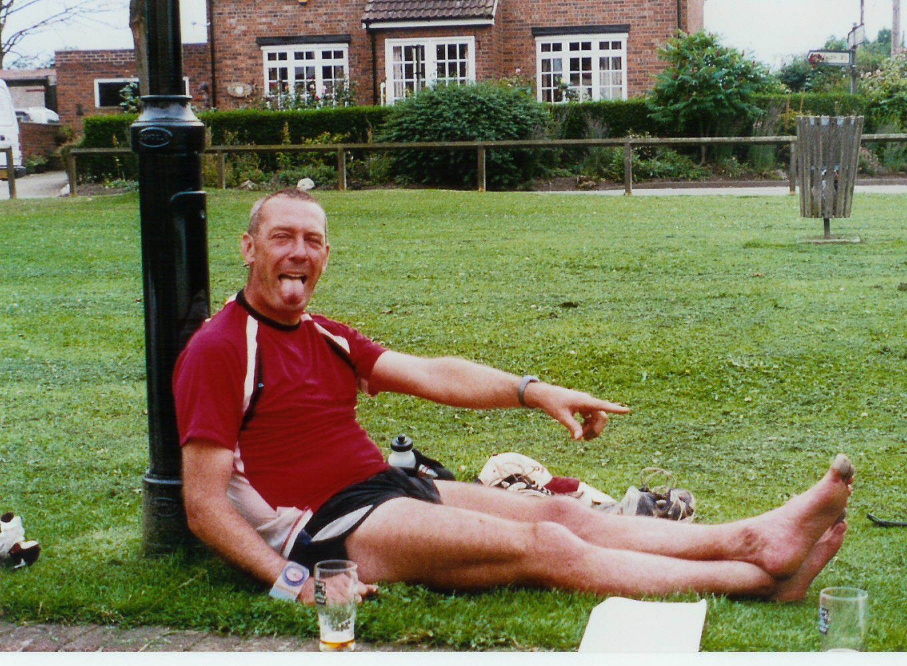

A few more miles of tarmac
And our ending is in sight
A tiring day, along the way,
Some times we were uptight.

But wait – there’s heroism here
There’s reason here for awe!
The silly sods decide, right now
To run a little more.

“Let’s add on a mile and a half;
No problem, guys – no pain.”
So we did.
And it started to rain.

The first rain since Ennerdale’s downpour
The first drop of sweet cooling tide.
Did the rain make us sprint for the finish?
Or the bull, in the field, near our side?

Hey, that’s 5 days gone…

Day 5, the least pretty (at least, the least spectacular)
Beautiful limestone cliffs early on – and herds of calves
Hostel buried in woods outside Osmotherley (yes, that’s the real name!)
Great pasta meal in the YH kitchen prepared by Anne, Simon, Tim, Jenny and Chris –included syrup sponge and custard!

End of day 5 – tragedy strikes.

Now think a while about the toll this takes -
Consider all the pounding, strains and aches;
We’ve heard as knees and ankles crack and fray
But now a new assailant has its evil way.

Simon, no doubt the toughest of us all;
That cough I mentioned, surely you recall?
So, which was the stronger of the two
Appalling news for us: it was the flu.

At the end of Day 5 Simon was forced out, with flu. Without him, this event would never have left our imagination; without him, the last two days simply weren’t the same.

But – you’ve guessed it – there may now be just five, but damn it, they still battled on.

Friday – Day 6

Day six, we breakfast, drive off to the start.
A sunny morning by the cattle gate.
We’re bouncy, lively, full of health and heart
Correct direction, then the running’s great.

More fields, and then the A19 with traffic roars -
Who’s quick enough to sprint to beat the cars?
We’re closing on the stunning Yorkshire Moors;
First down to Ingleby and find supporting stars
Who perk us up with balm and cups of tea,
As straight ahead we see an awesome climb.
Six peaks today! A test of heart and knee
But certainty of countryside sublime.

If you’ve never ventured on to Yorkshire’s moors,
Never seen the views, and never drunk the air,
Get there!
If you’ve never crossed the heather-covered hills
Never trod the stone on magic Cleveland way,
Do it!

So here’s our next to final day.
With Simon helping all along the way
We’re pushing legs to conquer brutal climbs,
With aches and gasps and serious pain at times.
Then on the tops, sky of blue and blazing sun
On the flat stuff we’re even seen to run…
…a little.

For Debbie it’s a mixed up day
With pain and poles for aid
But somewhere on her tortured path
A spirit briefly played.
She’s visited, she tells us
She doesn’t tell the name
Of t’moorland apparition
But it cheered her just the same.

But cheers
Rhymes with tears
And pain comes again;
So down the rugged hills
Exacerbates the ills.
Just get to the bus
There’s hugs there for us.
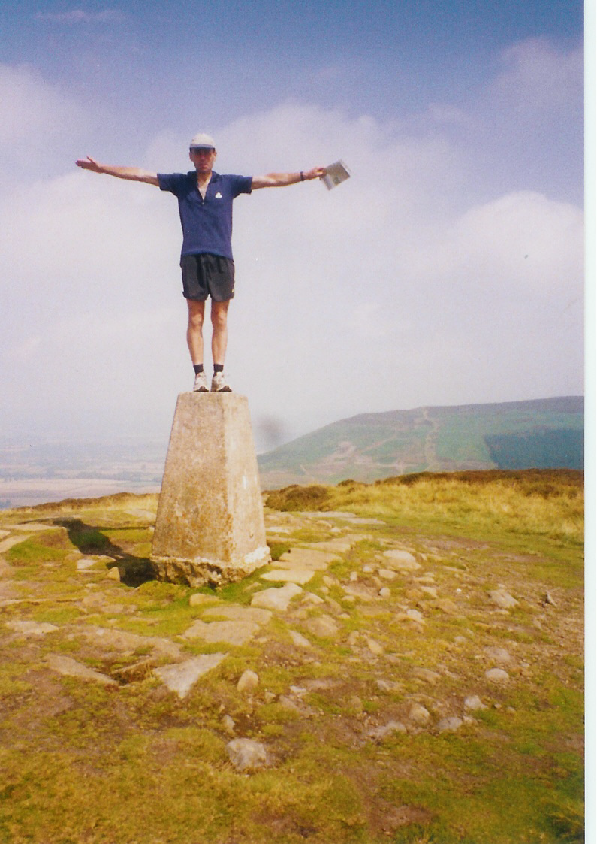
Pete standing on a trig point
The high point of the day?
Primary colour parascending
Sweeping across our way.
Food and drink and TLC
Heather’s purple haze
Ignore the run; forget the pain:
A most magical of days.

Jenny on a dry stone wall
Yells to say the bus is near!
But on the swooping hillside trail
Plodding runners fail to hear.

Later on the open moors
Calls were heard, of classic source:
“Heathcliffe!” is the cry from Nic
“Cathy!” back, from Chris of course.

We’ve talked of Debbie and her knees
We know that Simon’s got the flu.
A mention here for others’ pain
It’s X certificate, not U.
Nic bandaged tight on both her knees
Chris with a blister’d toe or two,
I’ve kept the legs in ok shape
But now it’s Pete who’s feeling blue.

The fit one, always there for us
Seems to be slowing as we run;
Never one to make a fuss
It turns out that a knee he’s done.

Listen, runners, you all know
How it feels as you get nearer
To the end, few miles to go.

We know at last the long day’s end
Is coming soon, along this track,
Maybe just around this bend?

We’re on the workers’ railway track
No mining here for many years
We’re spreading out, from front to back
Some distance ‘tween us soon appears.
It’s that old Wardell bloke again
He’s miles ahead, on springing legs
While at the back, Deb’s dragged by Paul
Her knees are feeling like the dregs.
While Nic and I just jog along
We’re marking off the streams and burns
Pete’s stepping out as best he can
The ancient rail track twists and turns

Dry crunched their trainers on the stony track
Past heath and gorse and heather
While all to left and right
The bare bleak moors sighed round them
Sad at the sight of struggling runners.
But - on the lo!
The Lion Inn;
And the long glory of a pint of best.

The Lion Inn:
Oh lovely sight
I’ll have a comfy bed tonight.
A soothing bath, that would be great;
A filling meal upon my plate.

A rest, some beers,
Good laughs and smiles;
Tomorrow’s only thirty miles!

So – Day 6?

A really great day in many ways.
Amazing scenery across the moors.
Another quote of the week – “Pain, pain, pain – it’s only f*****g nerve endings!” (Debbie)
Stunning Cleveland Way path, paved with beautiful York stone slabs
Joanna came to dinner with us at the Lion Inn – and paid for all our meals!
Despite the loss of Simon, we were a good team today.
Ros and Lizzie arrive to meet Simon, have dinner with us.
There was some genuine battling done today – many miles covered in pain.

And to the Final Day – there were those who doubted we’d get this far.
But, having made it here, we had little option:
We had to keep battling on.

Saturday – Day 7

There’s nothing, short of an earthquake, that will stop them battling on now.

Saturday morning
Rise and ache;
Hope the breakfast chef’s awake.
It’s a misty, foggy day,
Sad as Simon drives away.
Let’s get going,
Come on, chop chop –
Where is Debbie? In the shop?!
Buying postcards?
Flippin ‘eck,
Then the lady has to check
That her shoes are tightly tied
And her poles are at her side.
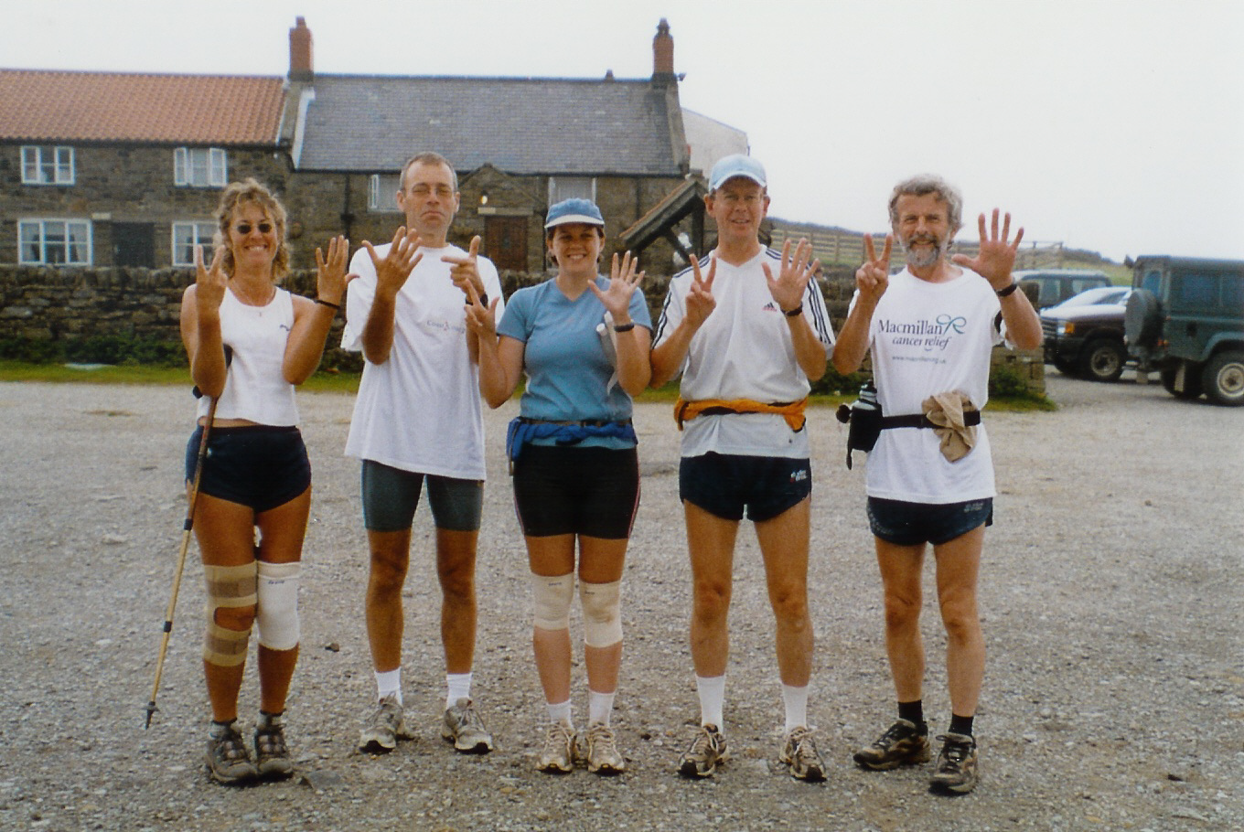
Now we’re running, slowly into misty morn;
Strangely silent, oddly out of sorts.
Our legs are weary, and our minds are worn -
It seems we’re smothered, deep in foggy thoughts.

What to say about our final day?
Foggy moorland, standing stones and heather;
Rise and fall through countryside that’s grey
Edges blurred by misty Yorkshire weather.

Still the aches, still the creaking and the pain -
Walking poles, knee strapping used again;
Some can jog, while others trudge along
Not a day, as yet, for jolliness or song.

On difficult terrain, some navigation tough
The climbs at times seemed quite unfairly rough.
For lunch, a pleasant spot supporters found,
Close by, a tempting local cricket ground.
Forget the run, let’s linger here in hope
To watch the match from by the boundary rope.

No – off again, not far to go
The pace is quite distinctly slow;
But miles are ticking gently down
And soon we’re into Grosmont town.
Where travel takes a slightly different theme
Parading engines from the days of steam.

We’d like that power to help us leave the town:
Guess what – the entry way was down,
And just like all the runs you’ve ever done
Up follows down as sure as night does sun!
The sun’s now beginning to warm us
It’s lifting the mist from the day
But despite the new brightness around us
The track’s still unclear on our way.

We’re lost on a heather clad hillside
There’s dozens of tracks we could choose,
But after a number of detours
We found the correct one to use.

A few weary miles now to finish
A few stops for help on the way
Our spirits are starting to lighten
We see signs marked “Robin Hood’s Bay”.

The day’s getting grey now, and cooling
And Debbie is struggling to run;
You can tell when the lady’s not fooling:
She goes quiet – then you know it’s not fun.

And somehow we lose her near Hawkser
We wait after rounding a bend
But no sight of Debbie behind us
And no sign of Paul, our new friend.
So Tim’s sent to search for the lady,
He charges around in the van
While the rest of us head for the coastline -
We try to keep warm while we can.

The good news is Debbie’s located
She will follow, with Paul by her side.
So now Nic and me, Chris and Peter
Are pushing to get to the tide.

Another long pull to support stop
And a last cup of strengthening tea
Then a caravan site, not our stop for this night
And a track leads us to the North Sea.

Can’t believe it! We’ve crossed all of England.
Down below is the water, quite grey.
Just a headland or two, though it’s not yet in view
Is that Mecca called Robin Hood’s Bay.

When we get to the town it’s amazing:
All the folks out for Saturday fun
Seem to know why we’re here
And they give us a cheer
And we skip to the end of the run!

You have to believe that it’s stunning
When you’ve been jogging way out of town,
To discover that folks recognise you
It can lift you when you’re feeling down;

But “down” wasn’t how we were feeling
Oh no! It’s a magical high:
Believe it, folks, we’ve nearly made it.
The end of the journey is nigh.

And heads turn, as down to the harbour
Strange runners are heading with ease;
You forget about crumbling ankles,
You forget about agonised knees.

You can count off the yards as you’re running
It’s a matter of moments to view
The water so grey
It’s called Robin Hood’s Bay;
And you’re met by your wonderful crew!

They’ve got banners and sparklers and bubbly
They’ve got kisses and hugs and huge smiles
They’ve been wonderful, brilliant supporters
For just under two hundred miles.

We made it!
Hey, Chris, mate – we made it!
Nic, I told you you’d get here, you see.
Hug Jenny, hug Anne, pop the champers
And then shoes off and into the sea.
And then Debbie arrives on her crutches
And it’s smiles and the pains disappear
And there’s Pete and there’s Paul and onlookers
And half of East Yorkshire is here!

A gang of odd cross-country runners
By the seaside on Saturday night;
Champagne, aching feet and mad laughter
Not your regular Robin Hood sight.

And did those feet, in year 04
Run across England’s mountains green?
And was the minibus, so white
With whoops of sheer delight there seen?
And did the Marlborough Runners team
Blaze trail across that wondrous land;
And did they make the run, feel like fun?
YOU BET THEY DID – AND IT WAS GRAND!

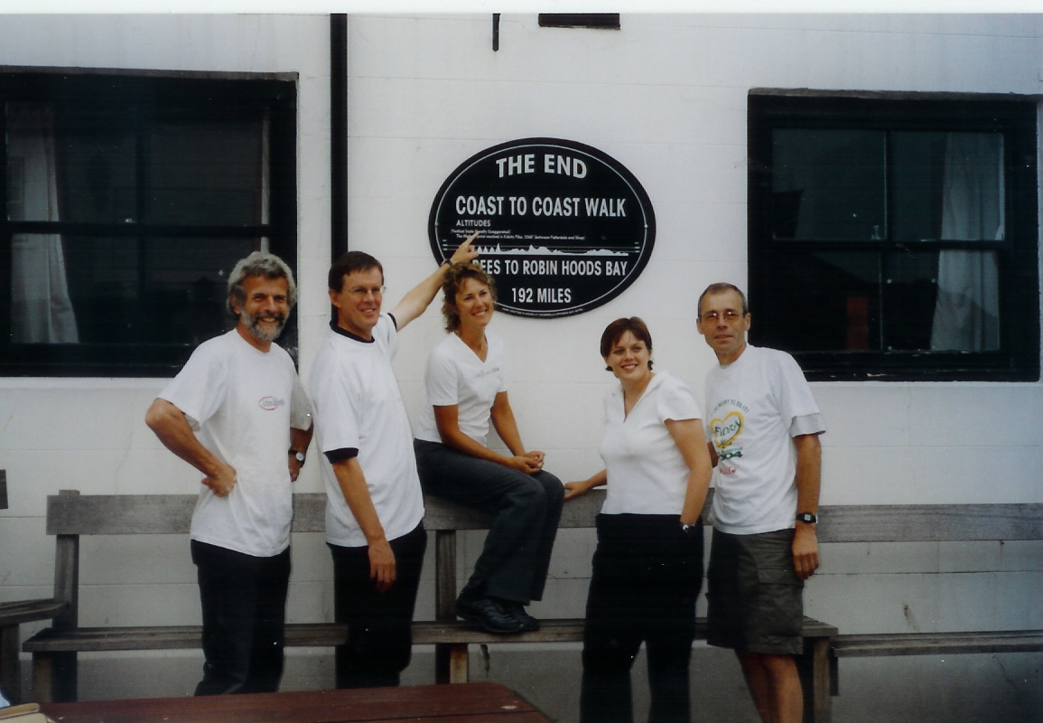

© Phil Griffiths, February 2005.

